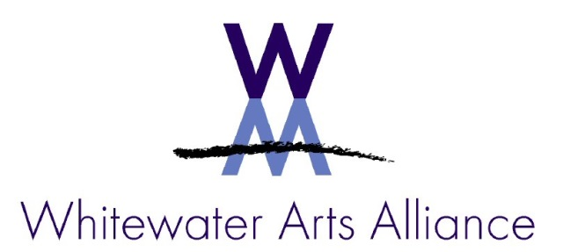

NEWS RELEASE Contact: Mary Nevicosi, 608-883-2000
Pubic Art Project Kicks off January 27
(WHITEWATER- January 7) On Sunday, January 27 at 2:30 p.m. the Whitewater Arts Alliance will kick-off its 2019 Public Art Project- Portals to the Past: Portals to the Future of Our Community, with a special presentation by Carol Cartwright, at the Cultural Arts Center, 402 West Main Street. Cartwright is a local historian and president of Whitewater Historical Society. Cartwright will inform and inspire prospective public artists with an interesting look back at Whitewater’s history.

The portals are to be painted on plywood boards measuring 24 x 42 inches. The plywood for the boards will be provided free of charge to anyone who wishes to participate in this annual project.

The art will hang during the summer from the light poles in the downtown area. Each artist can include a story of his/her vision, and it will be included on the Whitewater Strive On app. Strive On utilizes the GPS on smartphones and will take individuals on a walking tour of the portals.

The annual public art project aims to provide a fun way for businesses, individuals, families and friends to participate in a fun and educational experience. Artists are encouraged to make their portals creative, whimsical, colorful, and fun!

The Whitewater Arts Alliance will have materials and instructions ready for pickup on January 27 at 2:30 p.m. If an artist would like to participate but can’t transport the boards, an Arts Alliance member will deliver them. Opportunities to sponsor a portal will also be available. This is one of the major fund-raisers for the WAA each year.

The boards will also be available at the Cultural Arts Center during gallery hours, Thursdays through Sundays from 12:00 p.m. to 5:00 p.m. beginning February 1 during the Quilt Show.

The mission of the Whitewater Arts Alliance is to promote the visual and performing arts through an alliance of artists, individuals, educational resources, and organizations to promote creativity and diversity that will serve to educate and enrich the lives of the residents of the Whitewater community and surrounding areas.
###

